We would appreciate your feedback on Print iT 2019/2020

Name:

School:

Do you feel that students benefitted from Print iT?

Did they find it interesting?

Did you find it easy to teach?

Are there any other tools of information that would have been useful?

Does your school use an online learning platform, and if so which one? (ie Moodle, Artbox etc)

Do you prefer an online resource of a printed workbook?

Do you prefer to post completed projects, or do you find electronic communication more convenient?

Are there any extra modules that you would like to see in Print iT 2018?

Would you like more interactions during the year – say on-going mini competitions or quizzes?

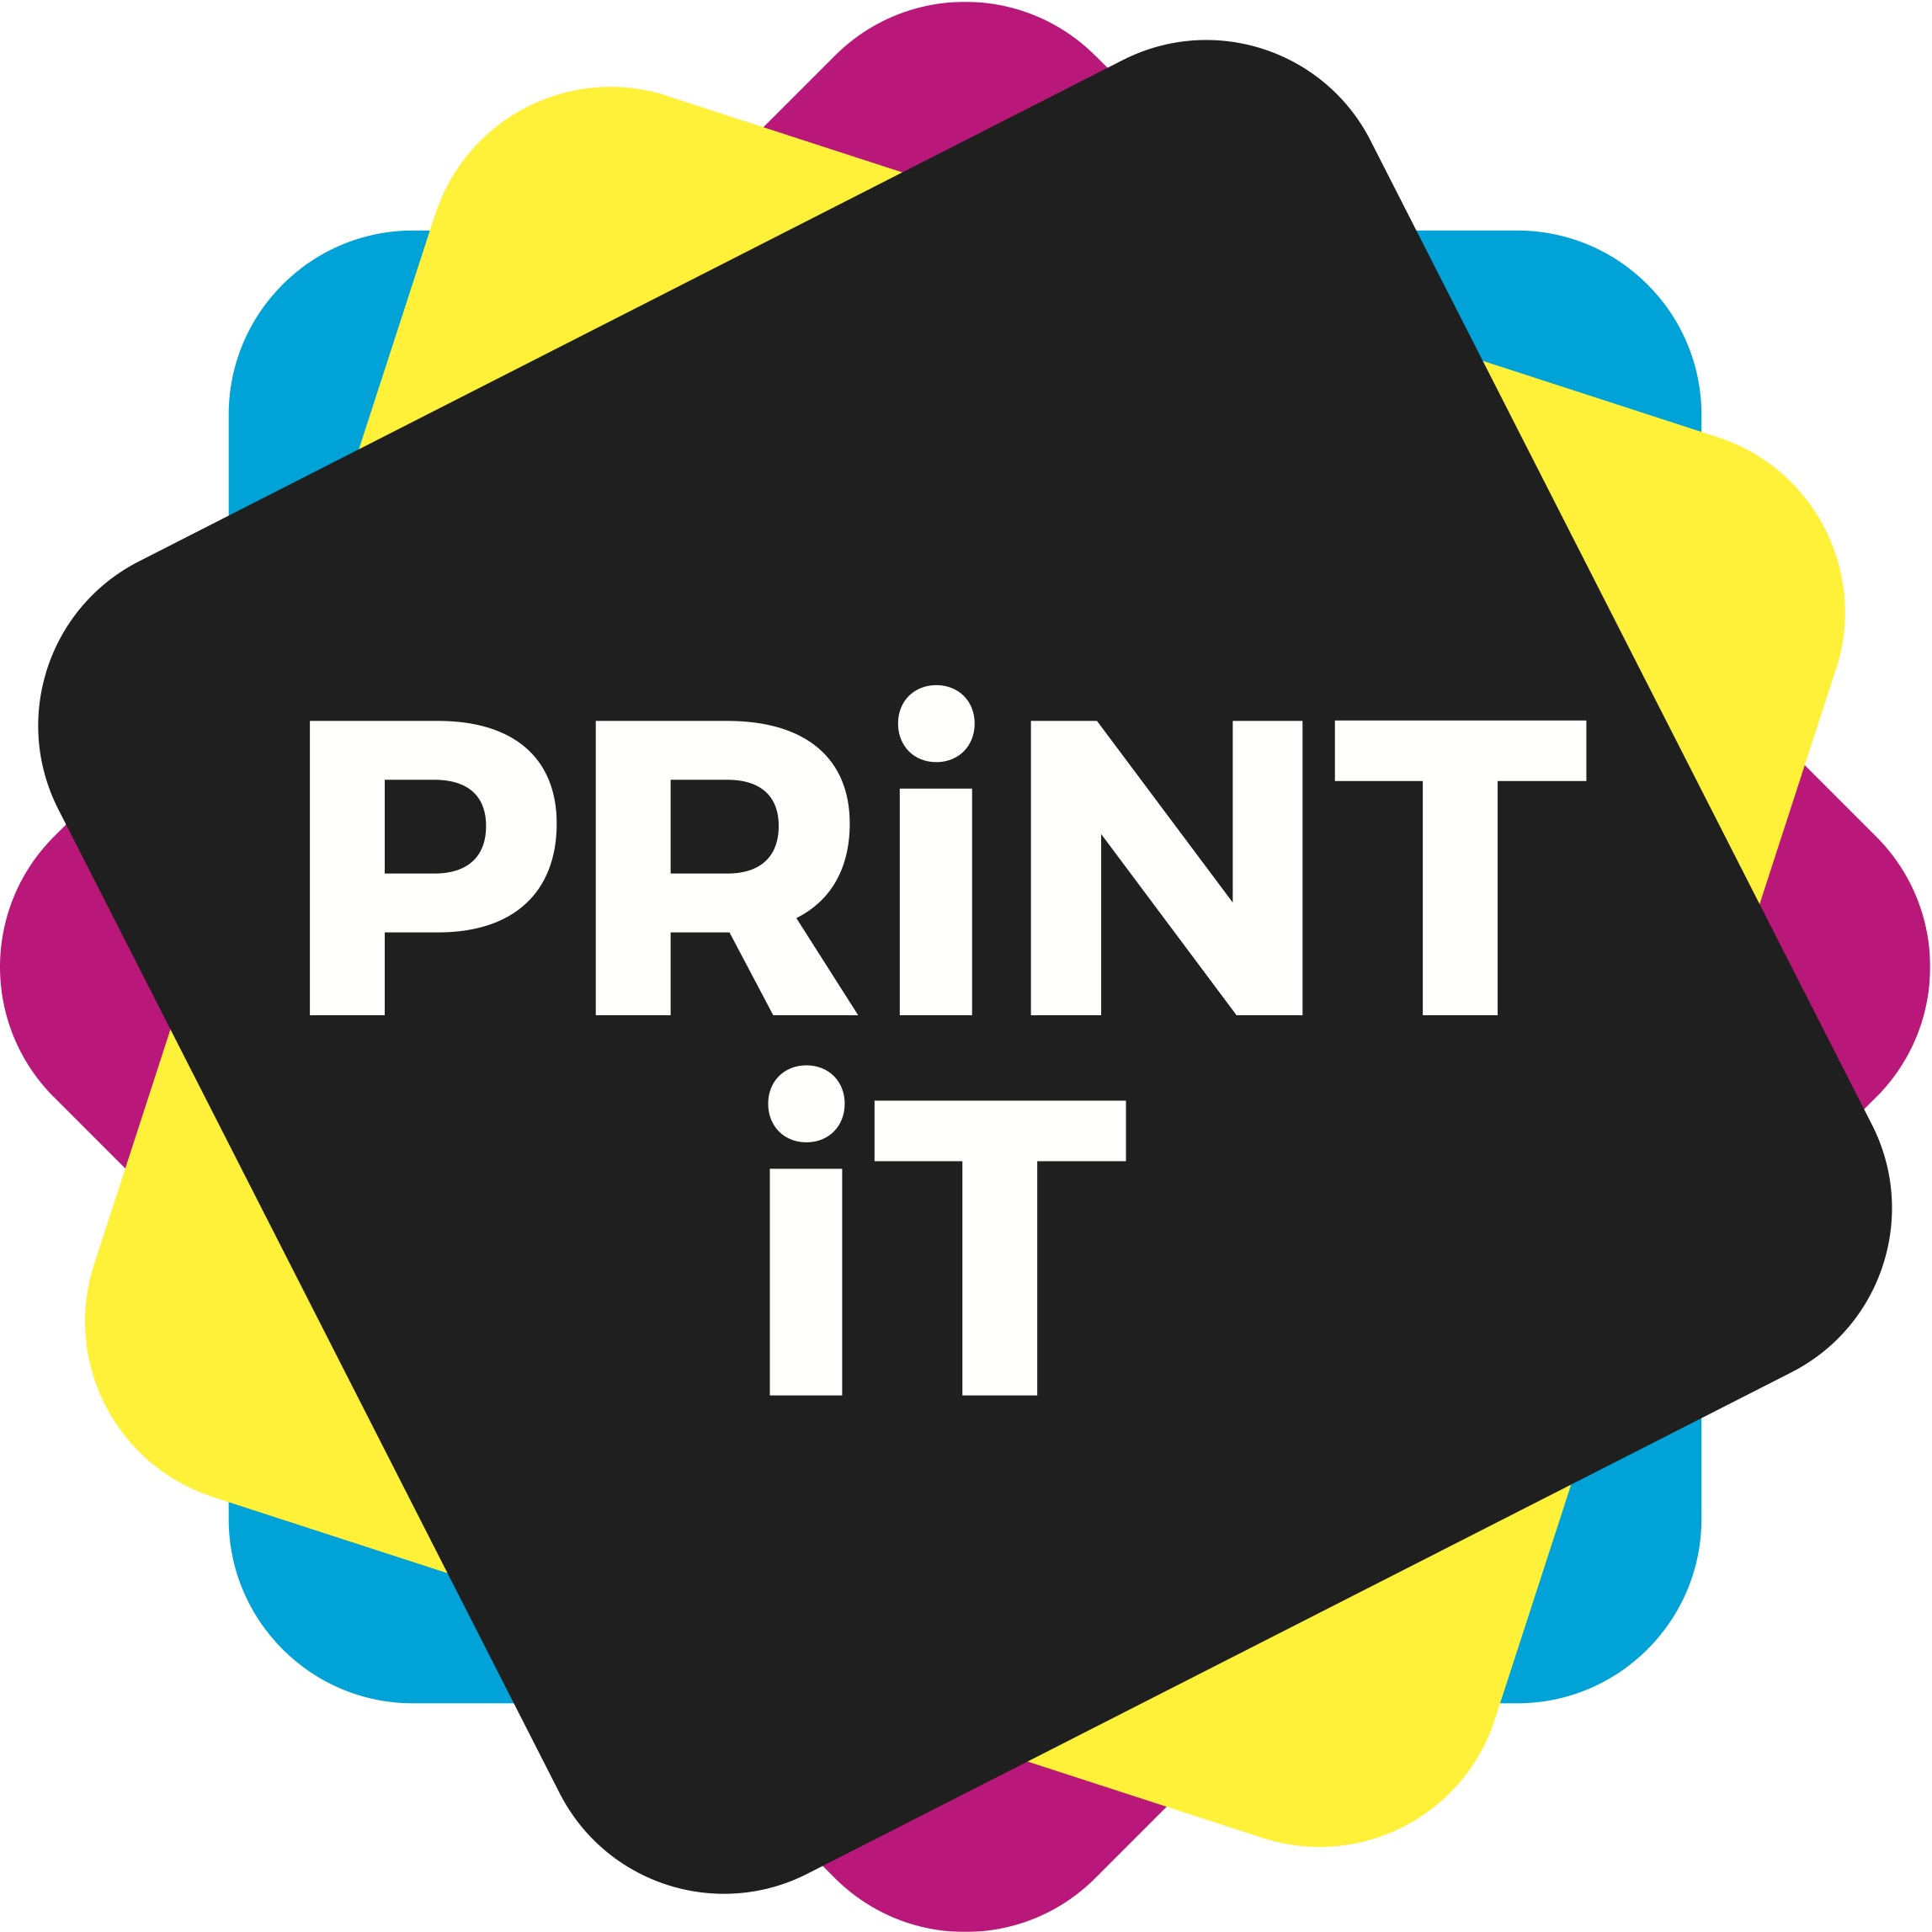
Thank you!

