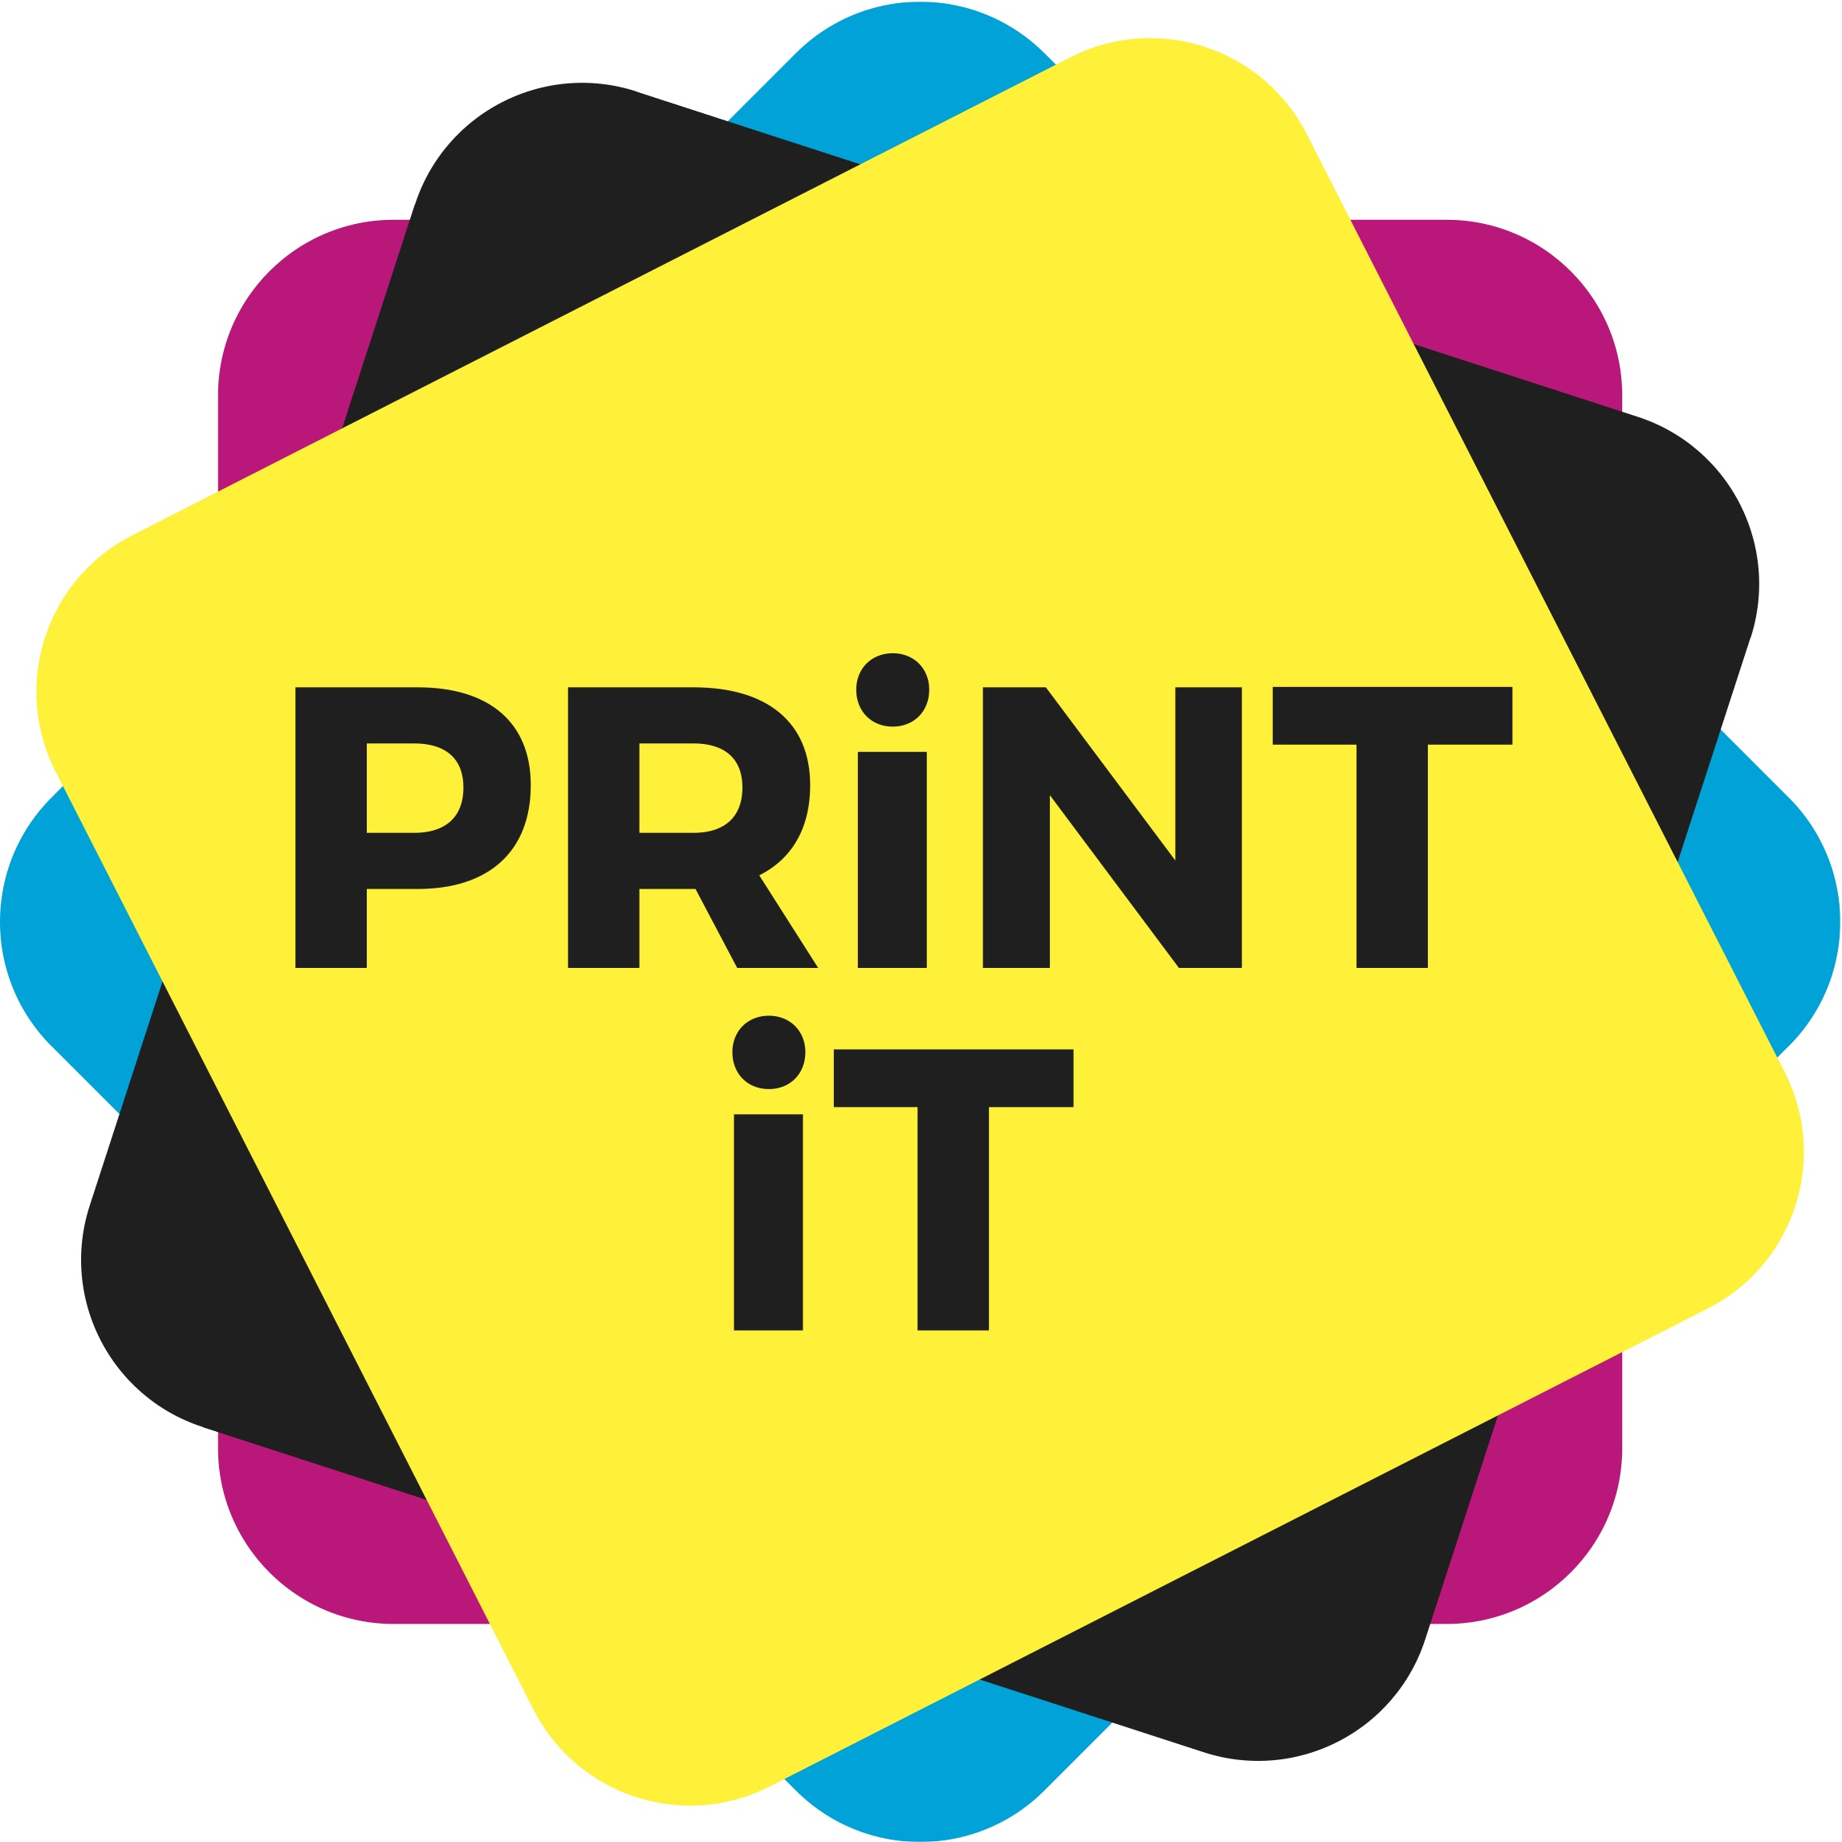

Printing processes: the technical bits in more depth

Offset
Litho printing was invented in 1798 and is based on the principle that ink and water do not mix. Artists would paint onto flat stone (lithos is the ancient Greek word for stone) using an oily paint or ink. Water was applied to the stone, followed by a coating of oily ink which was attracted to the oily image area and repelled by the water-covered non- image area. Paper was then pressed onto the surface to create a print before wetting and inking the stone for the next print.
The term ‘offset’ denotes the way that the inked image is transferred from the printing plate to the material via an intermediate rubberised blanket, which allows very fine images to be transferred at high speeds. The printing plate carries the image which works on the same principle as the original stone, with the image area attracting ink and repelling water (oleophilic and hydrophobic) and the non- mage area attracting water and repelling ink (oleophobic and hydrophilic). Each colour is printed separately on one printing unit and multi-colour images are created by overlaying inks one after the other, building up to full colour by the time the sheet reaches the last printing unit as it passes through the press. The main process inks are cyan, magenta, yellow an dblack (CMYK – K is for black being the ‘key’ colour)
Sheetfed litho can print sizes from B3 up to B0.

Digital
Digital imaging, using computers to create and reproduce an image, has transformed all of the printing techniques described above. Litho and flexo printing both now use computer to plate technology to make printing plates direct from PDF files, eliminating lengthy processes which required a series of colour separated films to be exposed, developed and shone onto the plate before developing the plate. Gravure cylinders can be automatically engraved without manual intervention by computer controlled engraving lines. Screen stencils can be imaged directly via computer, using either an inkjet head to apply a heated wax or ink which fills in the non- mage areas or a laser beam to remove the emulsion to reveal the image area. Even rotary letterpress formes can now be made using a computer to plate system to create a photopolymer plate which replaces the traditional forme.
But digital technology has brought about a whole raft of new printing techniques which come under the heading of digital printing. This can be inkjet or laser based, which can be summarised as follows:

Inkjet
An inkjet head sprays a fine jet of ink onto a substrate as it passes the head, forming characters and pictures in multiple colours by using multiple inkjet heads. Most printers used with home computers use inkjet technology, but industrial inkjet printers are very sophisticated and can print to a very high resolution and in very wide formats, up to five metres wide! Most home use inkjet printers use water based inks but industrial printers tend to be solvent based to allow faster drying at higher speeds. Some models use special UV sensitive inks which cure immediately on exposure to UV light, enabling them to print on a wide range of materials. The third main type of ink used is called dye sublimation and is used for printing onto polyester or acrylic based fabrics, as the dye in the ink ‘sublimates’ (changes from gas to solid) and bonds to the fibres of the fabric when heated. The ink can either be applied directly to the fabric or via a carrier sheet.
Industrial digital inkjet printing is used for all sorts of short to medium print runs of almost anything, provided the quantity is not too great.

Laser
Laser printers use toner based inks which are attracted to an electrostatically charged print image area on a roller drum and are then transferred to the material. Heat is used to fuse the inks to the surface, allowing the material to be handled immediately.

There are two major advantages of digital presses over conventional ones.
The first is that they have no initial set up costs, other than formatting the data to drive the printer. All of the traditional printing methods require an original from which copies are made – a plate, a cylinder, a forme, a screen – and the cost of preparing the original and making the press ready means that small runs incur a very high initial charge, making the unit cost prohibitively high. A four colour litho job needs four plates to be made and set up on the press, which can cost hundreds of pounds, depending on the size of the plate. If you only need a few copies, the set up cost will be very high per copy. Digital printing can print just a single copy, or up to several hundred copies very economically. Currently, digital presses can only run at a fraction of the speed of litho presses, so once the print quantity reaches the break even point where the set up cost plus the running cost of conventional presses is the same as the running cost on a digital press, then the conventional press will print each subsequent copy at a fraction of the cost of the digital press. However, technological advances are allowing digital press manufacturers to run faster and it has been predicted that digital will be able to match some litho presses in terms of quality and output speeds within the next 10 years.
The second advantage is that every copy printed on a digital press can be different from the copy printed before it, allowing personalisation to be driven by databases which can make the printed item appeal to each person receiving their personalised copy. This allows companies to target their printed marketing towards each client, increasing the chances of the client taking up their offer. If your database tells you a potential client’s favourite colour and type of car they drive, you can create a personalised printed mailer with their initials on the number plate of their ideal car in their favourite colour! New technologies enable printer fonts to be created from almost any image, so a potential client’s name can be printed using letters which look like they have been created by hand, such as pebbles on a beach or a tattoo on someone’s arm. This type of highly targeted print personalisation is significantly more expensive per copy, but marketing companies tend to print much smaller quantities using accurate databases instead of mass mailing to many thousands of people who will not have any interest in their product. This is a better for the environment as it uses less resources and as the technology improves and personalisation costs decrease, this area of digital printing, known as variable-data printing, is set to grow exponentially.

Gravure
Gravure printing is a widely used printing process. Whereas litho uses a planographic (flat) surface to transfer the image, gravure uses an intaglio (Italian = cut in) surface, where the image is etched or engraved into a hard surface, using ‘cells’ (holes) of differing depth. The ink is applied to the surface area and a doctor blade is used to squeegee the excess ink from the un-etched surface, leaving ink in the cells which form the image area. The deeper the etching, the more ink it will hold. The material to be printed is then applied to the surface and the ink is deposited. More ink can be applied that is possible using litho, so deeper colours can be achieved and surface imperfections of the material can be covered over by the heavier film of gravure ink. Rotogravure denotes a printing press which uses a cylinder which is etched or engraved and reels of paper (or other materials) are fed through the press where the inks are printed in sequence one after the other using one printing unit per colour.
Gravure printing is used to print high quality magazines, catalogues, wallpaper, postage stamps, laminates for kitchen worktops, vinyl flooring and for printing onto fabrics. The quantity must be very large (usually several hundred thousand impressions) to justify the high set up cost of producing the etched cylinders.

Screen printing
Screen printing, also known as serigraphy, uses a fine mesh stencil wrapped tightly over a frame. The mesh allows ink to pass through unless it is filled in or blocked. A simple stencil can be made by applying a non-permeable material to the areas which are not to be printed (non image areas). Most industrial stencils are made by coating the stencil with a photosensitive emulsion, then shining a bright light source through a film containing a positive image of the area to be printed onto the stencil. The non image area which is exposed to the light turns solid (fixed) and the stencil is then washed to remove the unfixed emulsion, leaving the image area open which allows ink to pass through.
The stencil is loaded into the screen press, where ink is applied to the surface and forced through the image areas using a hard rubber squeegee blade. The ink is deposited directly onto the material under the stencil. For short runs of a few hundred items, simple ‘handbench’ machines are used. The material is inserted under the screen manually and the operator squeegees the ink through by hand, one impression at a time. For longer runs and multi-colour prints, semi or fully automatic screen presses feed the material, squeegee the ink and can even dry the ink using ovens or UV light.
Screen printing is used for printing on fabrics, metals, plastics – almost any material can be screen printed. Even the printed circuit boards used in computers and other electronic equipment are printed using the screen printing technique. One of the limitations of screen printing is that the size of the holes in the mesh prevents fine dots from printing cleanly and very small type fonts can “break up” even when using the finest mesh stencil.

Flexography (flexo)
Flexography uses flexible printing plates (sometimes referred to as stereos), usually made of a dense rubber or flexible plastic, on which the image is raised to transfer the ink. The non image area is exposed to UV light shone through a film containing a positive image of the area to be printed, which is placed onto the plate surface so that the right-reading side is in contact with the plate. The exposed area is then washed in solvent to remove a layer of the plate surface, leaving a raised reverse (wrong reading) image of the original film. The plate is mounted onto a cylinder which rotates to pick up the ink and then transfer it to the material.
This process uses thinner inks than litho so drying is faster, but quality of flexo printing is usually lower than litho or gravure as the image can squash as the material is forced against the flexible plate. Advances in technology have recently closed the quality gap and some modern flexo presses, using the latest photopolymer plates can almost rival litho and produce sharp dots with a wide tonal range, at high speeds. Common uses for flexo printing include labels, cartons, flexible packaging, corrugated and gift wrap.

Letterpress
Letterpress is the oldest form of industrial printing, invented in the 15th century. The idea behind letterpress was to use movable type locked into a frame. Each letter was cast or carved individually and placed in order into the frame, called a forme, to form words and spaces. The type was raised in mirror image and the forme was inked before applying a sheet of paper with pressure behind to transfer the ink. Letterpress printing revolutionised society and made books available to the masses, not just the elite.
The industrial revolution brought advances to the letterpress process with automatic inking and pressing, using a hinged platen onto which the operator placed the sheet of paper which was pressed onto the forme. By the 20th century rotary presses increased productivity by allowing the paper to be fed over an impression roller, allowing continuous production at much higher speeds. Type, which was previously assembled by hand, was cast and automatically assembled on type casters using a keyboard to create punch tapes which were fed into the caster to create a line of type. This would either be linotype, where the whole line was cast as a block (called a slug), or monotype where each character was cast and assembled individually.
Letterpress has been widely replaced by litho and flexo and many letterpress printing presses have been converted for sequential numbering, die cutting or foil blocking and embossing. There are thousands of printers in the UK who still use letterpress machines in this way, but only a few still print using this traditional method.
Letterpress printing has seen a resurgence in the last few years, but for ‘craft’ or ‘art’ pieces such as one off greetings cards or high end wedding invitations.

With thanks to Greenprint Consultancy for help with this section.

