The Brief
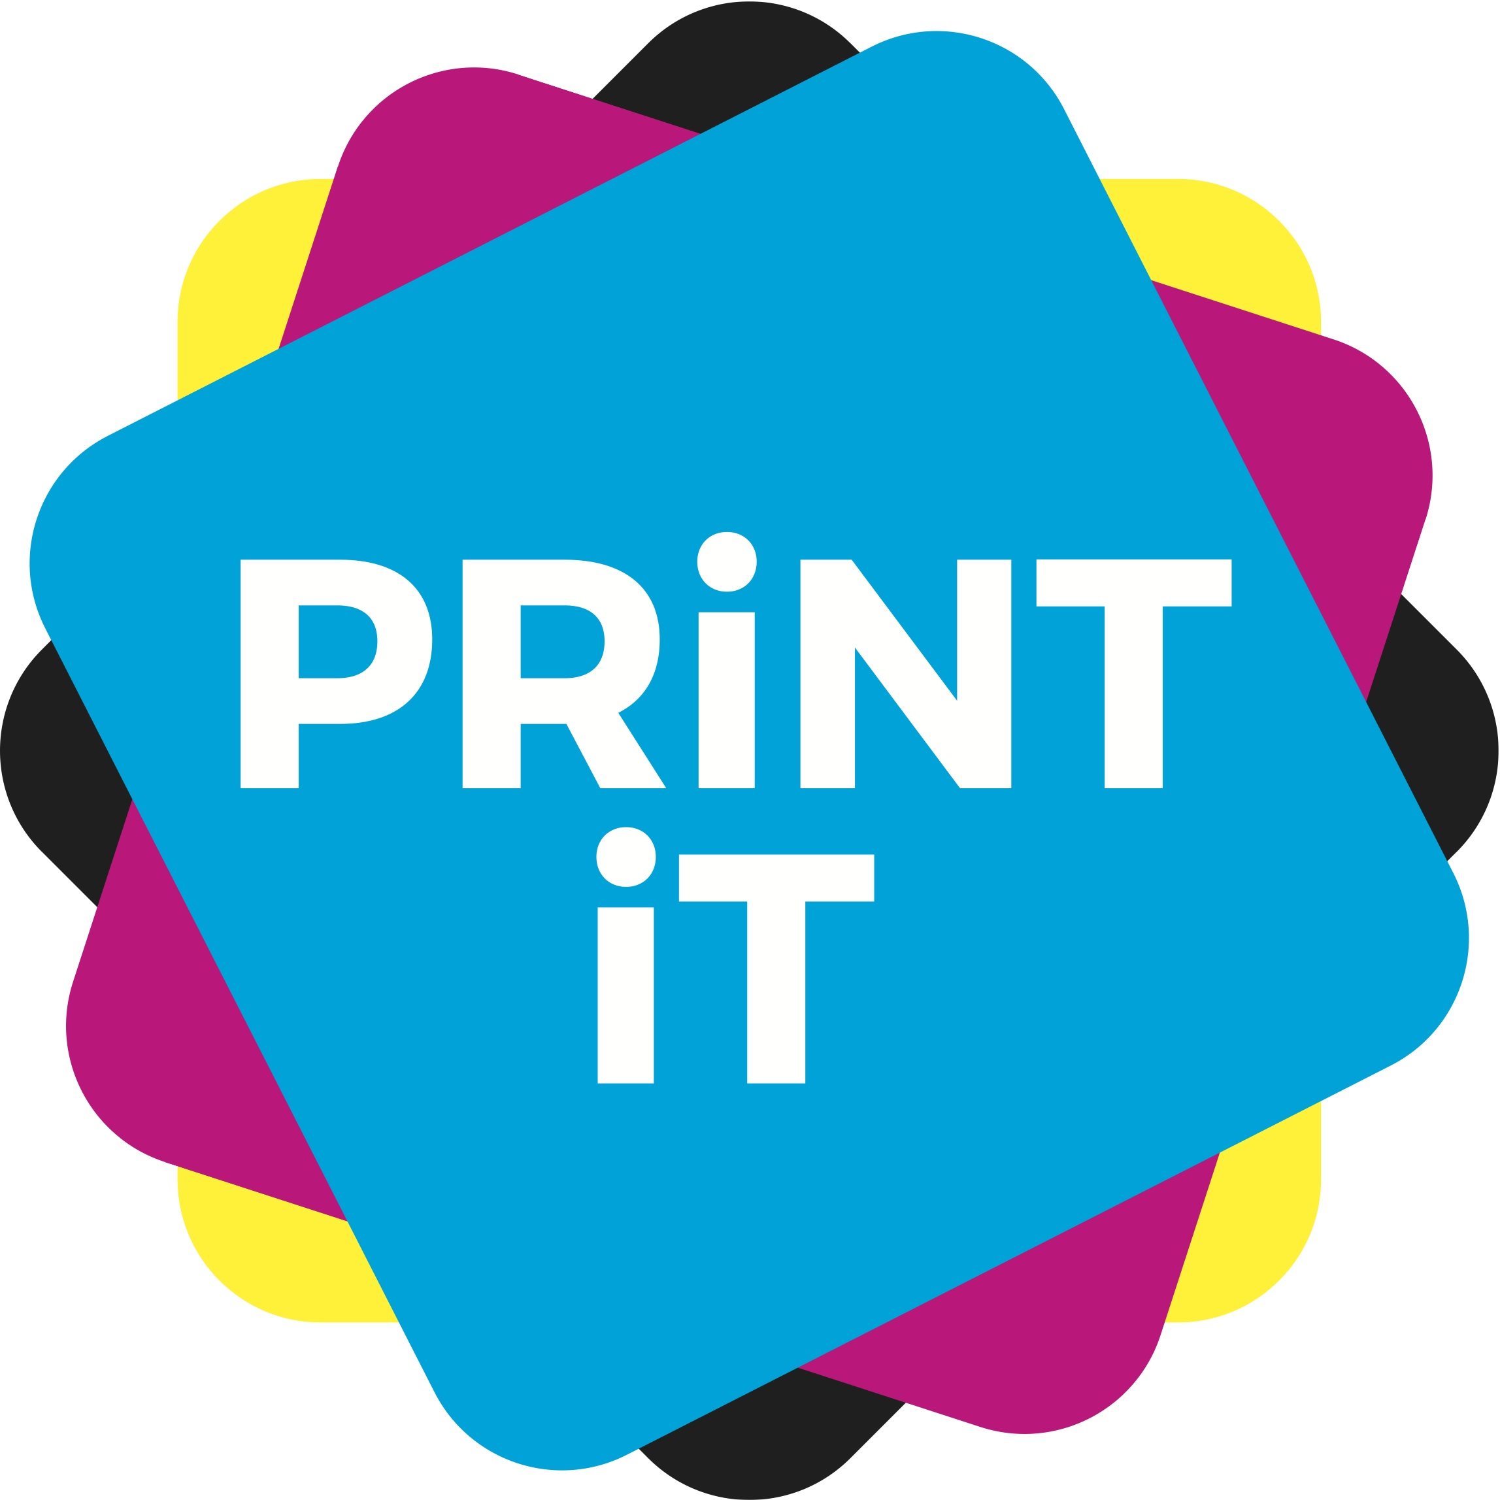

Unit 1 starting your virtual business:

There are three categories to choose from – sports, gaming, and music.

Sports: We want you to launch a sportswear line. Decide on a ‘standout’ piece for this with which you will promote your brand/products. That could be a pair of trainers, a t-shirt, or other things you use for sports such as socks and wristbands, or even a water bottle.
Think about the elements of a sports brand and what it needs to convey: energy, healthy lifestyle, exercise, positivity.

Gaming: We want you to launch a computer game. Decide on the genre and this will help to set the style for promoting your brand/product.
Genres can include: Adventure role playing, strategy, life sim or puzzle. You can set the game in whatever location or time you wish – space, under the sea, fantasy world, ancient times, or in your school.
Think about the elements of a gaming business and what that brand needs to convey: excitement, leisure, action, adventure.

Music: We want you to launch a band or pop group. Decide on what your band will be like and what sort of genre of music it will play.
You need to market and promote this band to be the number one success worldwide.
Genres can include: Pop, indie, hip hop or heavy metal.
Think about the elements of music and what your brand needs to convey: enthusiasm, talent, appeal, popularity.

Print iT...
Choose one of the three categories in which to start your business and give it a brand name. Tell us why you have chosen this.

Design a brand logo.

Unit 2. Developing a marketing plan

The best way to develop your good brand ideas is to let people know about them and that means marketing, marketing, marketing. But, there are various ways to do this, and as a small start up business you will not have millions of pounds to throw at TV commercials, so what you do will have to fit a) with the vision and ethics of your brand, and b) with what you can afford.

Print iT...
You need to bring your brand to market.
Decide on the media channels to be used to promote it. Tell us the reasons why you have chosen these.

Design an advert.

Unit 3. Develop the following depending on your business choice.

Sports: Prototype packaging for your product.

Gaming: An eye catching box for the game.

Music: A poster for your band, along with CD cover.

Print iT...
Show us the design. Choose the one you are going with and tell us how you will produce these and what materials will be used.

Unit 4. Look at the environmental impacts of your marketing choices.

Step 5. Write a short press release to launch your brand, summing up why the market needs it and what your brand ethics are – what makes you different to your competition and why people should buy your product.

Print iT...
Design an invitation to the launch.

