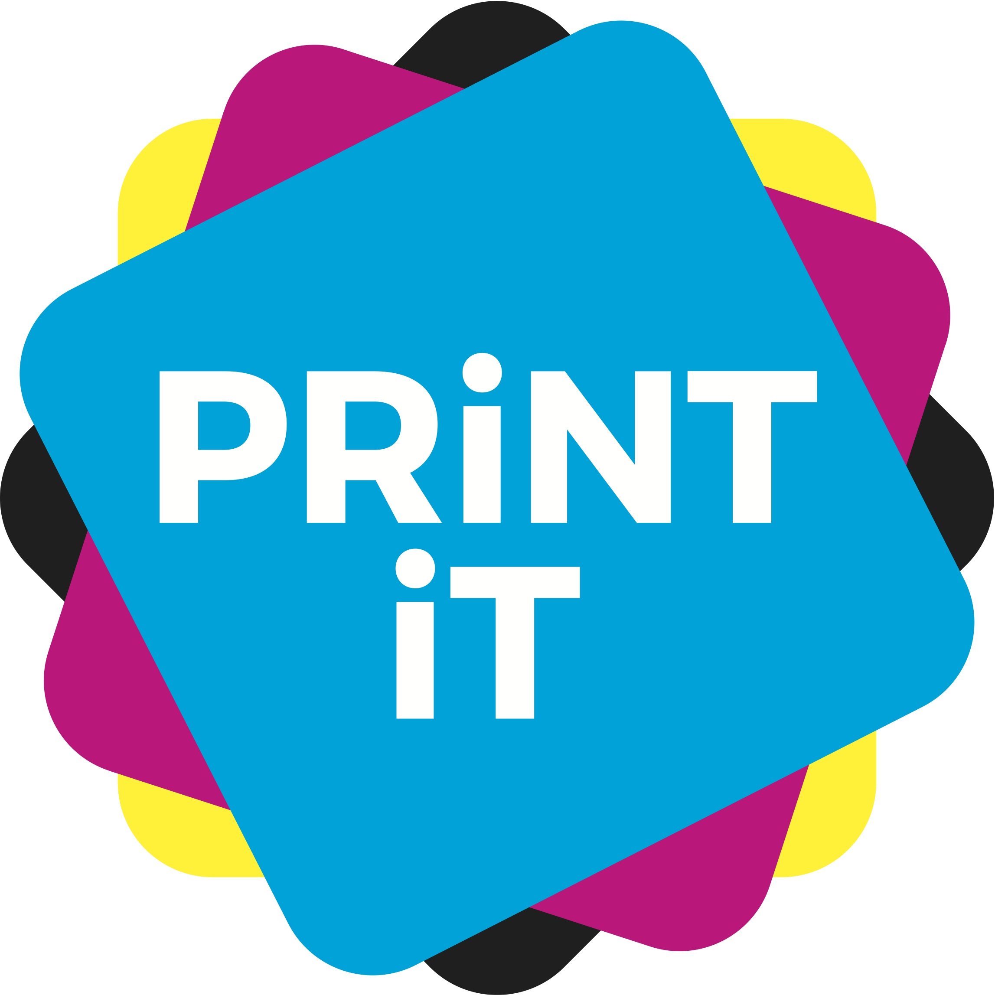
Paper made from trees

Trees are the breathing, living heart of this planet. That is not a woolly, ‘tree hugging’ statement, but a fact! Trees are essentially important to life on this planet, and whether you look on forests as an emotional issue, a scientific one, or a socio-economic one, the truth is that we cannot do without trees.
The graphic arts industry uses trees for the production of paper –undoubtedly the biggest consumable within most printing companies. We use a lot of it, but as part of the graphic arts, we also make a lot of it – and we are the world’s biggest planter of new trees.
The industry owns a lot of the forestlands, and we ensure that these are kept to the very best environmental standards – third party audited to credible international standards for sustainability and good environmental management.
Thankfully, the paper industry has taken responsibility here and has become a ‘shepherd of the forest’, increasingly working to higher and higher sustainability standards, setting aside land to encourage natural biodiversity, ensuring the health of its trees, and planting and growing new areas of forestland, so that it can ensure an unbroken natural resource for the future – this plainly makes good business sense if the industry wants to have raw materials for the future.

This industry is brilliant at coming up with creative ideas, at innovating and producing top quality products. Print on paper is about so much more that just communications or commodity products or clever applications. There is an emotional attachment between man and paper that goes back a long way into our history. Paper profoundly touches the senses – vision, touch, even smell.
Once your paper products have been produced, remember that they will continue to store C02 throughout their lives, just by sitting on a shelf or I a drawer – helping the environment even after manufacture.
Paper has a brilliant sustainability story to tell, and we should never forget that. Printed documents will never be bettered when used in conjunction with your imagination and creativity – ‘the world’s most powerful graphics chip, imagination’ (the words of Dr Sheldon Cooper, PhD, Big Bang Theory).

Paper can be made from almost any fibrous material. In its early days, much of it was made from textile rags and old rope. Come the industrial revolution and the need for much more paper, and tree pulp was used as it can be grown as a crop, is sustainable and can be replanted, regrown and reused.
However, there are lots of options for paper ranges that are either made form other materials, or have inclusions in them that are not tree based. Crops such as Bagasse (sugar cane residues), bamboo, cotton, hemp, even seaweed, as well as novelty ‘specials’ such as animal ‘poo’ (yes, and I am not joking), can be used successfully for paper production.
But even if we don’t branch out into using other raw materials, Two Sides points out that ‘European Forests have grown by over 30% since 1950 and are increasing by 1.5 million football pitches every year – an area four times the size of London’.
There are many uses for trees, but paper only directly takes up to 7% from construction waste’ (Food and Agriculture Organisation of the United Nations, FAOSTAT, 2011).

The paper industry continually spends millions of pounds, euros, dollars, on greening up its production processes. Most production plants and products are now certified to high environmental standards such as the internationally recognised ISO 14001, Forest Certification Scheme (FSC) or Programme for the Endorsement of Forest Certification schemes (PEFC), which are all independently audited for good practice).
As of April 2017, FSC has now certified nearly 194 million hectares of forest land in 80 countries across the world, whilst the latest figures from PEFC show some 300 million hectares of certified forests. That is a lot of forest that is being managed to high, credible and third party environmental standards.
Increasingly, paper makers are introducing recycled fibres from already used papers to create new substrates. However, you can only recycle paper fibres about five to six times before they become too brittle to use, and so some virgin fibre must be introduced into the production chain. These virgin fibres now, almost universally, come from forests managed to exceptionally high green standards and controlled and managed to ensure sustainable production. And paper makers don’t just chop down trees and chuck the whole lot into a pulper. The cut tree is sawn into timber for the building industry and the paper industry used thinnings, trimmings or off cuts from trees – bits of the crop that would otherwise be dumped or burned.
Many of these trees have been planted to harvest, much like a crop of vegetables, and when they are cut down, three or four are put back in their place. The paper industry therefore nurtures and husbands forests as one of their most important natural resources.
Paper is also often made with green energy, either through CHP plants or things like wind power, and the water used in production can be returned to rivers and is cleaner when put back in than when it comes out.
Perhaps also it would be good to point out, that not all trees make good paper. The Amazon forest for instance harbours many trees that are no use for papermaking, so do not believe all that you hear from the environmental organisations.
Whilst paper still uses energy, water and other materials in its production, and yes, you do need tree fibres to make it, it is a sustainable option, and it is environmentally friendly.

